Client Overview: India Pesticides Limited (IPL) is a prominent agrochemical company with a strong focus on quality and innovation in agricultural solutions. IPL operates facilities that include storage tanks for various chemicals crucial to their manufacturing processes. Given the nature of these chemicals, IPL prioritizes safety to mitigate risks associated with storage and handling, ensuring compliance with regulatory standards while maintaining operational efficiency.
Engagement of HSE Risk Management Services: IPL engaged HSE Risk Management Services Private Limited to conduct a comprehensive Quantitative Risk Assessment (QRA) for their storage tanks. The objective was to:-
- Determine the consequence impact due to equipment’s defined under scope of work
- Assess the risk on employees and surrounding public
QRA Methodology: HSE Risk Management Services utilized a structured approach in conducting the QRA:
- Hazard Identification: Identified potential hazards related to the storage and handling of chemicals, considering their properties, storage conditions, and operational practices.
- Risk Assessment: Quantitatively assessed the likelihood and consequences of identified scenarios such as leaks, spills, or fires involving hazardous chemicals using advanced modeling techniques.
- Safety System Evaluation: Evaluated the effectiveness of existing safety systems including fire detection, suppression systems, and emergency response procedures.
- Risk Mitigation Measures: Developed and recommended specific mitigation measures to reduce identified risks to an acceptable level, considering IPL's operational requirements and safety standards.
- Emergency Preparedness: Ensured IPL's readiness to respond effectively to emergencies through comprehensive emergency response planning, employee training, and coordination with local authorities.

QRA METHODOLGY
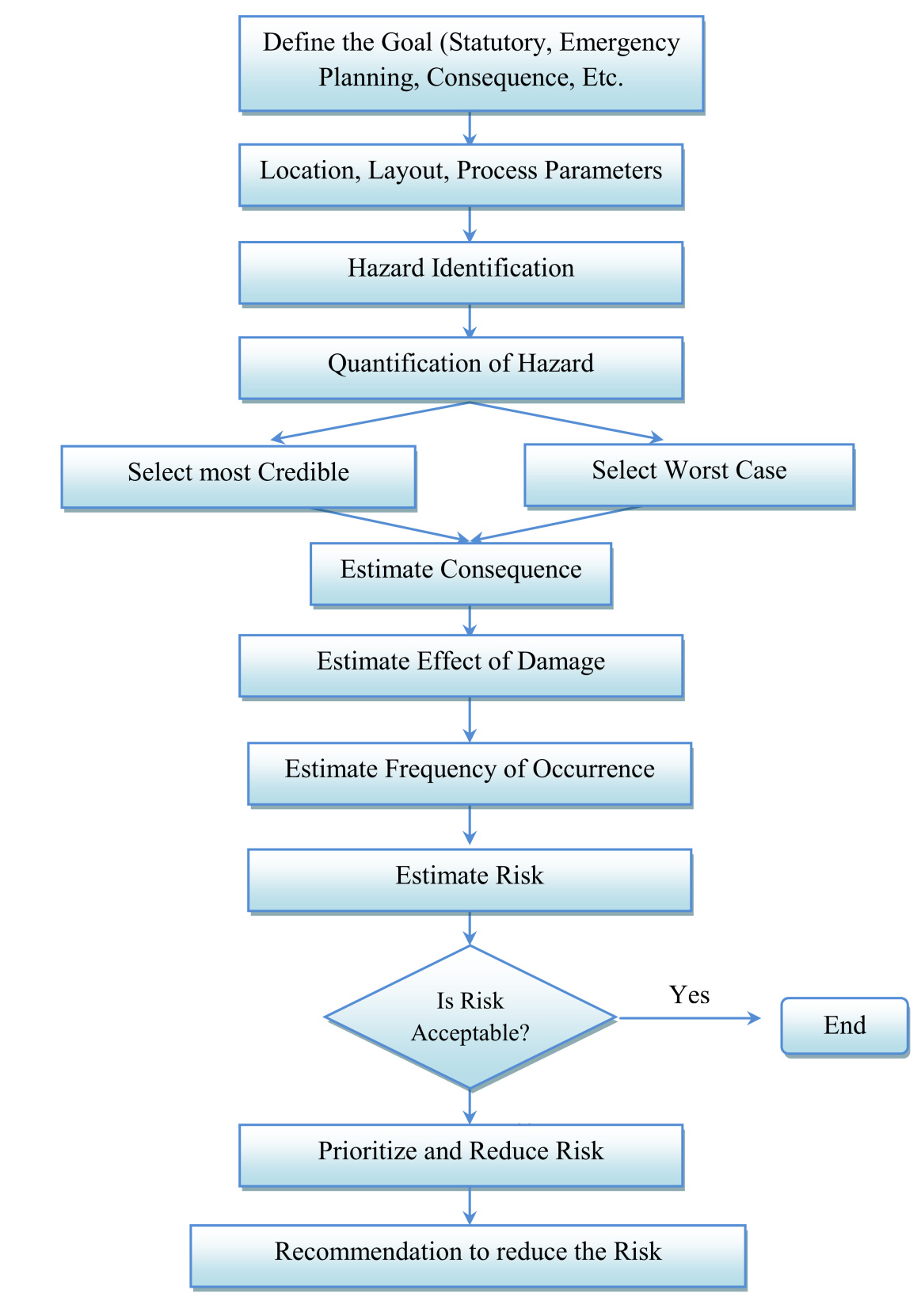
Challenges: Challenges encountered during the QRA process included:
- Ensuring accurate data availability on chemical properties, storage conditions, and operational procedures.
- Coordinating with IPL authorities to ensure compliance with safety standards and regulations.
- Balancing safety enhancements with operational efficiency to minimize disruptions.
Recommendations: Based on the findings of the QRA, HSE Risk Management Services proposed the following recommendations to enhance safety at IPL's storage tanks:
- Inventory Management: Optimize the inventory of chemicals to minimize risks while ensuring continuity of operations.
- Mechanical Integrity: Implement a robust preventive maintenance program to enhance the mechanical integrity of tanks and prevent potential leaks or failures.
- Fire & Gas Detection Systems: Install and maintain advanced Fire & Gas detection systems at critical locations to provide early detection of leaks or releases.
- Firefighting Systems: Ensure compliance with relevant standards (e.g., IS 3844 for internal fire hydrant and hose reel systems, IS 13039 for external hydrant systems) through regular maintenance and testing.
- Emergency Response Planning: Develop and implement a comprehensive Emergency Response Plan addressing various scenarios involving chemical releases. This includes employee training, establishment of mutual aid agreements, and regular emergency drills.
Outcome: By implementing these recommendations, IPL aims to strengthen safety measures, minimize risks associated with chemical storage, and enhance overall operational resilience. This proactive approach underscores IPL's commitment to maintaining high standards of safety and sustainability in their facilities, ensuring the protection of personnel, assets, and the environment.
This case study illustrates how IPL effectively utilized QRA to identify risks, improve safety protocols, and ensure compliance with regulatory requirements, thereby fostering a safe and secure environment for their operations.

